
Experiment no 7:Circular Linked List ADT

Aim:Implementation of Circular Linked List ADT

Objective :
Circular Linked List can be used to manage the Computing Resources of the computer. Data Structure such as stacks and queue are implemented with the help of circular linked list

Theory:
Circular Linked List
A circular linked list is a variation of a singly linked list where the last node of the list points back to the first node, creating a loop. This means that the last node's "next" pointer points to the first node instead of containing a NULL value. Circular linked lists can be advantageous in certain scenarios, such as implementing circular buffers or representing elements in a repeating sequence.
Main Function and User Interaction
- In the main() function, there is a menu-driven interface that allows users to:
  - Insert a new node into the circular linked list.
  - Delete the first node from the list.
  - Display the elements of the list.
  - Exit the program.
- The program continues to display the menu until the user chooses to exit, and it handles invalid choices by displaying an error message.

Algorithm:
Step 1: Create a structure for the linked list node with two fields: data and next.

Step 2: Declare global variables: newnode (to create new nodes), head (to store the head of the list), and temp (to traverse the list).

Step 3: Define the insert() function:
- Allocate memory for a new node (newnode).
- If memory allocation fails, print an error message and return.
- Prompt the user to enter data for the new node.
- Set newnode's next pointer to NULL.
- Check if the list is empty (head == NULL):
- If it is empty, set head to newnode and make it point to itself to create a circular list.
- If it's not empty, traverse the list to find the last node (temp) and update its next pointer to newnode. Then, make newnode the new last node.

Step 4: Define the display() function:
- Initialize a counter variable (count) to 0.
- Set temp to the head of the list.
- Print "Elements in the circular linked list are: ".
- If the list is not empty (temp != NULL), do the following:
- Start a loop:
- Print the data of the current node.
- Move temp to the next node.
- Increment count by 1.
- Continue the loop until temp becomes equal to the head again.
- Print the number of nodes (count).

Step 5: Define the deleteNode() function:
- Check if the list is empty (head == NULL):
- If it's empty, print an error message ("No element to delete from the node") and return.
- If the list is not empty:
- Traverse the list to find the last node (temp) while keeping track of the current head.
- Update the next pointer of the last node (temp) to point to the second node in the list (head->next).
- Print the data of the deleted node (the previous head).
- Free the memory occupied by the previous head.
- Update the head pointer to the second node in the list.

Step 6: In the main() function:
- Initialize a loop that repeatedly displays a menu for user choices:
- Insert a new node (call insert()).
- Delete a node (call deleteNode()).
- Display the list (call display()).
- Exit the program.
- Handle invalid choices.
- Repeat the loop until the user chooses to exit.

Step 7: End the program.

Code :
:#include <stdio.h>
#include <stdlib.h>
struct node
{
int data;
struct node *next;
};
struct node *newnode, *head, *temp;
void insert()
{
newnode = (struct node *)malloc(sizeof(struct node));
printf("Enter the data: ");
scanf("%d", &newnode->data);
newnode->next = 0;
if (head == 0)
{
head = newnode;
newnode->next = head;
}
else
{
temp = head;
while (temp->next != head)
{
temp = temp->next;
}
temp->next = newnode;
newnode->next = head;
}
}
void display()
{
int count = 0;
temp = head;
printf("Elements in the circular linked list are: ");
do
{
printf("%d\t", temp->data);
temp = temp->next;
count++;
} while (temp != head);
printf("\nNumber of nodes: %d\n", count);
}
void delete()
{
if (head == 0)
{
printf("No element to delete from the node\n");
}
else
{
temp = head;
while (temp->next != head)
{
temp = temp->next;
}
temp->next = head->next;
printf("Deleted node data is: %d\n", head->data);
free(head);
head = temp->next;
}
}
int main()
{
int ch;
while (1)
{
printf("\nEnter your choice\n1. Insert\n2. Delete\n3. Display\n4. Exit\n");
scanf("%d", &ch);
switch (ch)
{
case 1:
insert();
break;
case 2:
delete();
break;
case 3:
display();
break;
case 4:
exit(0);
break;
default:
printf("Invalid choice\n");
break;
}
}
return 0;
}

Output:
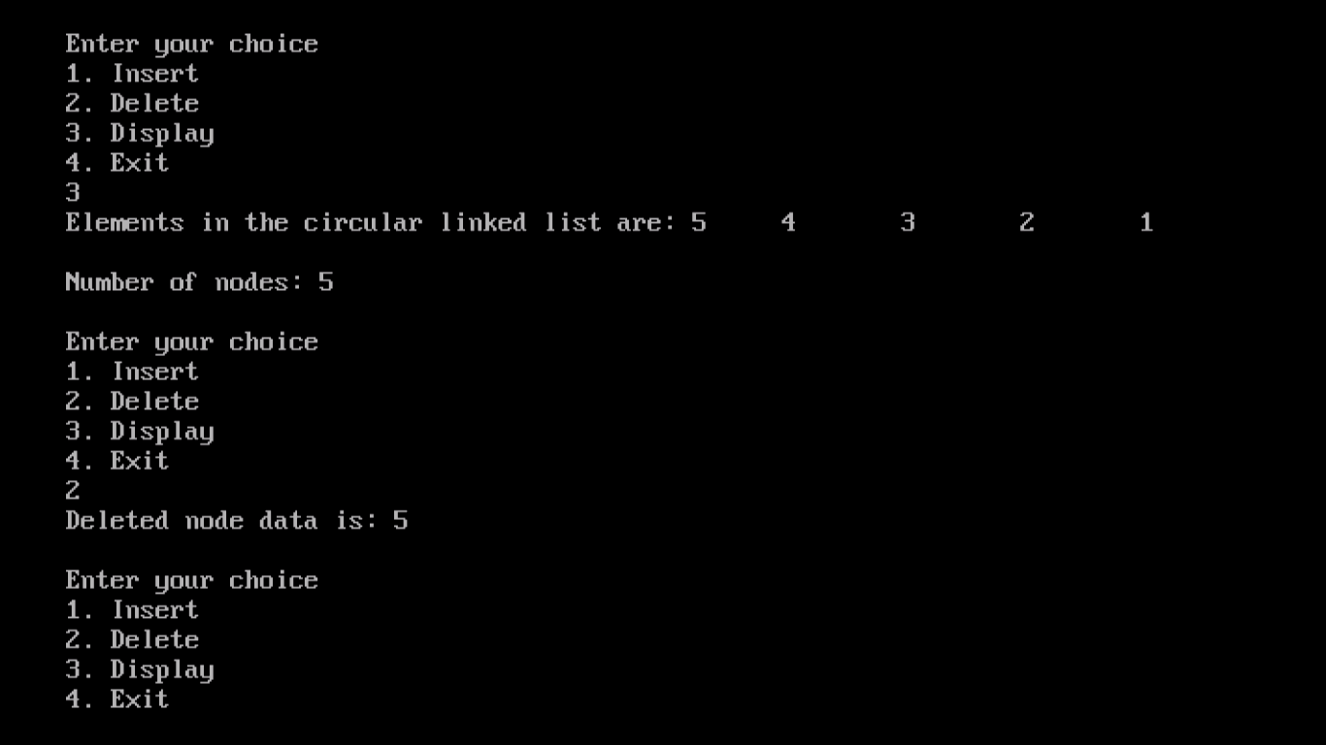

Conclusion :
In summary, this code demonstrates the implementation of a circular linked list with basic operations, providing a practical example of how linked lists work in a circular context. Users can interact with the program to insert, delete, and display elements in the circular list, and it maintains the circular structure throughout these operations.

